ST-510 胶囊咖啡机
2.净重： 2.91kg /pc
彩盒:35.1x14.4x28.2cm
外箱:59.4x36.1x29.6cm（4个装）
- FOB顺德32.1美金
- 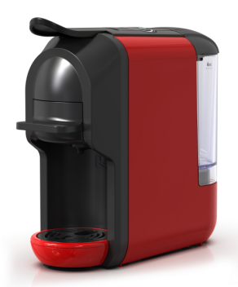
6.MOQ500

产品配置说明：
1. Power: 220-240V~50Hz,1450W /100-120V~60Hz,1450W
2. Water capacity: 0.6L
3. Transparent removable water tank
4. 19 bar pump
5. ON/OFF main switch
6. Short Espress/Long Nespresso with LED.
7. Can manually stop or auto stop
8. Patented brewing group & design
9. Stand by for 15 minutes
10. Indication when ready to brew.
11. Energy saving model according to Erp2.
12. Selection for available adaptor :
Nespresso Compatible Capsules
Dolce-Gusto Capsules; Coffee poweder
Coffee pod; A MODO MIO; Lavazza Blue; Caffitaly, K cup, Bialetti

1. ST-512 胶囊咖啡机
2.净重： 2.91kg /pc
彩盒:30x14.3x27.9cm
外箱:59.5x31.5x29.5cm（4个装）
4.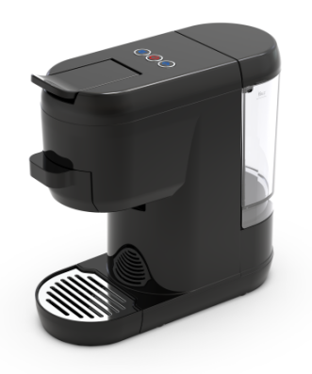
- FOB顺德32.1美金
- MOQ500

产品配置说明：
1. Power: 220-240V~50Hz,1450W /100-120V~60Hz,1450W
2. Water capacity: 0.6L
3. Transparent removable water tank
4. 19 bar pump
5. ON/OFF main switch
6. Short Espress/Long Nespresso with LED.
7. Can manually stop or auto stop
8. Patented brewing group & design
9. Stand by for 15 minutes
10. Indication when ready to brew.
11. Energy saving model according to Erp2.
12. Selection for available adaptor :
Nespresso Compatible Capsules
Dolce-Gusto Capsules; Coffee poweder
Coffee pod; A MODO MIO; Lavazza Blue; Caffitaly, K cup, Bialetti

1. ST-544 胶囊咖啡机
2.净重： 2.91kg /pc
彩盒:30x14.3x27.9cm
外箱:59.5x31.5x29.5cm（4个装）
4.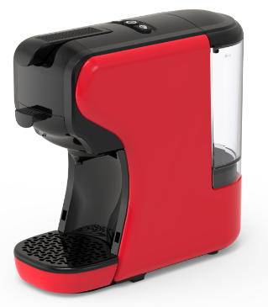
5.FOB顺德32.1美金
6.MOQ500

产品配置说明：
1. Power: 220-240V~50Hz,1450W /100-120V~60Hz,1450W
2. Water capacity: 0.6L
3. Transparent removable water tank
4. 19 bar pump
5. ON/OFF main switch
6. The cold/hot brew function can be switched. (Optional function)
7. Input and eject capsule manually
8. Indication when ready to brew.
9. Energy saving model according to Erp2
10. Selection for available adaptor :
Nespresso Compatible Capsules
Dolce-Gusto Capsules; Coffee poweder
Coffee pod; A MODO MIO; Lavazza Blue;
Caffitaly, K cup, Bialetti

1. ST-550S 胶囊咖啡机
2.净重： 3.9kg /pc
彩盒: 387×167×309mm
外箱: 688×404×334mm（4个装）
4.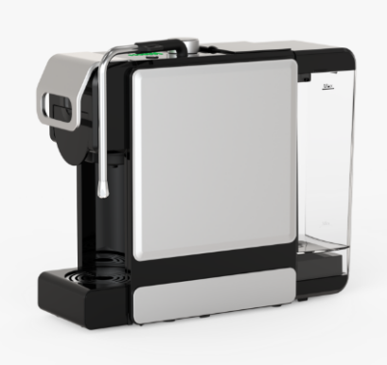
5.FOB顺德49.5美金
6.MOQ500

产品配置说明：
1. Power rating: 220-240V 50/60Hz 1450W.
2. Water capacity: 1 L.
3.Transparent removable water tank.
4.19bar pump
5. Steam/hot water functiong
6. Input and eject capsule manually
7. Indication when ready to brew.
8. Energy saving model according to Erp2
9. Selection for available adaptor :
Nespresso Compatible Capsules
Dolce-Gusto Capsules; Coffee poweder
Coffee pod; A MODO MIO; Lavazza Blue;
Caffitaly, K cup, Bialetti

- ST-550M 胶囊咖啡机
2.净重： 4.3kg /pc
彩盒: 363×244×301mm
外箱: 753×382×326mm（3个装）
4.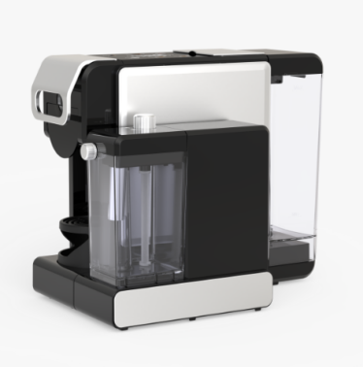
5.FOB顺德55.7美金
6.MOQ500

产品配置说明：
1. Power rating: 220V-240V~; 50/60Hz; 1450W
2. Transparent removable water tank, capacity: 1L.
3.Transparent removable milk tank. capacity: 300mL.
4.15bar/19bar pump
5. Thermoblock with PID temperture control
6. One touch cappuccino function
7. Custom coffee volume
8. Adjustable milk foam fineness
9. Removable dirp tray
10. Touch screen on top
11. Cold drink (water does not pass through the thermoblock) (optional function)
12. Air pump remove residual water of the capsule (optional function)

- ST-554M 胶囊咖啡机
2.净重： 3.4kg /pc
彩盒: 43.3x15.9x32.7 cm
外箱: 49.2x44.8x34.7 cm（3个装）
4.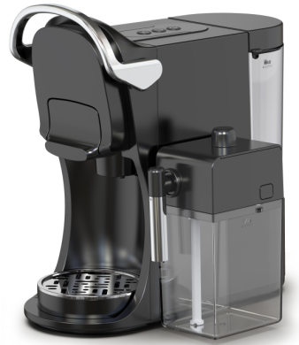
5.FOB顺德43.9美金
6.MOQ500

产品配置说明：
1. Power rating: 220V-240V~; 50/60Hz; 2850W
2. Transparent removable water tank, capacity:
3. Transparent removable milk tank. capacity:400mL.
4. 19bar pump
5. Thermoblock with PID temperture control
6. Removable dirp tray
7.Selection for available adaptor :
Nespresso Compatible Capsules
Dolce-Gusto Capsules; Coffee poweder
Coffee pod; A MODO MIO; Lavazza Blue;
Caffitaly, K cup, Bialetti

1.ST-502 单一雀巢胶囊咖啡机
2.净重： 2.9kg /pc
彩盒: 40.1x14.5x259cm
外箱: 60x41.5x27.5cm（2个装）
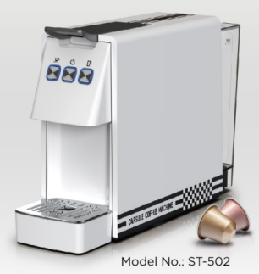
5.FOB顺德31美金
6.MOQ500

产品配置说明：
1.Power rating:230V/50Hz, 1450W
2.Water capacity:0.6L
3.Transparent removable water tank
4.19 bar pump
5. On/Off switch with illumination
6. Short Espresso (40ml) /long Espresso (90ml) with LED in white, volume can be customized
7. Capsule auto ejection system
8. Can manually stop or auto stop
9. Patented brewing group & design
10. Energy saving model according to Erp2

1.ST-694B 意式咖啡机
2.净重： 9kg /pc
彩盒: 348X186X340mm
外箱: 582X362X360 mm（3个装）
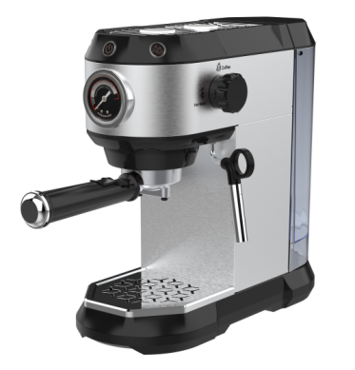
5.FOB顺德38美金
6.MOQ500

产品配置说明：
Specification:
1.Power rating: 1450W.
2.Water capacity: 1 L.
3.Transparent removable water tank.
4. 15bar Pump
5. Pressure gauge show brewing pressure timely
6. Hot water for cup cleaning
7. Steam for milk frother
8. Top warming plate for cup warming
9. One-touch control panel with illumination.
10. Auto shut off / energy saving
11. With 51mm Aluminium normal coffee powder handle

- AC-517KA (Single boiler) 胶囊咖啡机带磨豆组件
2.净重：6KG
包装尺寸: 385x385x525mm（单台装）
4.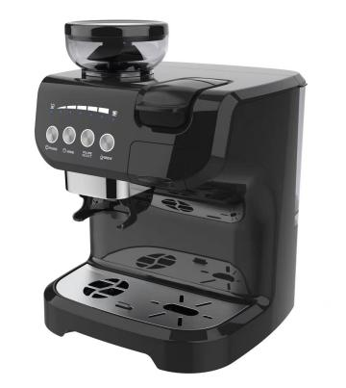
5.FOB顺德97.4美金
6.MOQ300

产品配置说明：
Specification:
1.Power rating: 1560W.
2.Water capacity: 2 L.
3.Transparent removable water tank.
4. 19 bar Pump
5. Input and eject
capsule manually
6. Compatible with different system
7. Coffee powder holder receive fresh coffee powder from grinding unit
8.Grinding unit can use as bean grinder
9. Auto shut off / energy saving
10. Selection for available adaptor :
Nespresso Compatible Capsules
Dolce-Gusto Capsules; Coffee poweder
Coffee pod; A MODO MIO; Lavazza Blue;
Caffitaly, K cup, Bialetti

- AC-517KB (With milk steam pipe and double boiler) 胶囊咖啡机带磨豆组件
2.净重：6KG
包装尺寸: 385x385x525mm（单台装）
4.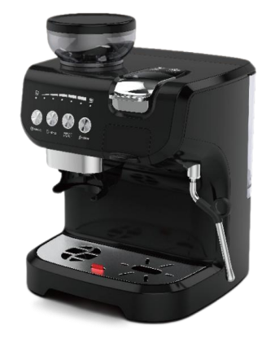
5.FOB顺德126.44美金
6.MOQ300

产品配置说明：
1.19bar Pump
2.Water capacity:2L.
3.Coffee Maker power:2672W
4.Grinding Coffee power:150W
5. Removable water tank and drip tray make for easy cleanup.
6. Input and eject capsule manually.
7. Compatible with different system.
8. Use the steam function to frothing milk for cappuccino.
9.Makes espresso and cappuccino preparation quick and easy.
10. Coffee powder holder receive fresh coffee powder from grinding unit.
11.Grinding unit can use as bean grinder.
12. Auto shut off / energy saving.
13.220-240V~50/60Hz Machine Size:
WXHXD=311×390×406mm
14. Selection for available adaptor :
Nespresso Compatible Capsules
Dolce-Gusto Capsules; Coffee poweder
Coffee pod; A MODO MIO; Lavazza Blue;
Caffitaly, K cup, Bialetti

- GML1001 磨豆机
2.毛重：6.34KG
包装尺寸: 267*260*405mm
4.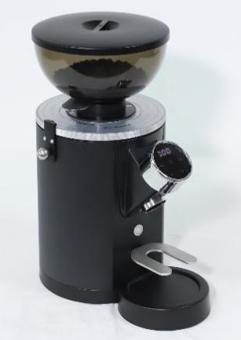
5.FOB顺德92.8美金
6.MOQ300

产品配置说明：
Parameter: 220V/50Hz/250W
1. quickly remove the grinding disc, clean the coffee powder does not affect the grinding scale; 2.11 grinding thickness can be adjusted;
3. 500g visual bean warehouse;
4. 60mm stainless steel cutter;
5.can set manual \ single and double cup powder time
6.magnetic suction straight fall powder channel design, powder fluffy without caking; 7. touch screen control, LCD display time;
8.with automatic locking grinding disc, accurate locking grinding scale; 9.powder rate 1.25g/s

1.GML1007 磨豆机
2.毛重：6.95KG
包装尺寸: 258*256*508mm
4.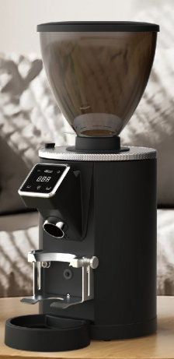
5.FOB顺德107.53美金
6.MOQ300

产品配置说明
1.Voltage/Frequency:220V~50Hz Rated power:350W
2.Quick release grinding disc,cleaning coffee powder does not affect the grinding scale.
3.16 grinding coarseness adjustable.
4.Can be set manually/ single and double cup powder time
5.Magnetic straight down powder channel design, fluffy powder without lumps.
6.Touch screen control,digital screen display time.
7.WEith automatic lock grinding disc, accurate lock grinding scale.
8.64mm stainless steel blade
9.750g visualisation bean bin
10.Powder rate 2.8g/s

